**M08 Software Solution - Test Case and Screenshots - Group 2**

**Test Case:**

1. Home Screen:
   1. Press the “Click to Start your event!” button
2. Login Page:
   1. Enter Unique Username:
      1. For this test case, we will use “TestUserGroup2”
      2. There must be a unique username for the application to work
   2. Enter the Event Coordinator's Name
      1. For this test case, we will use my name, “Xander”
   3. Enter Event Name
      1. For this test case, we will use “My Wedding”
   4. Press “Get Started” Button:
      1. This action will allow you to save your data and go to the next page
3. Details Page:
   1. Enter Event Location
      1. For this test case, we will use “Fort Wayne, Indiana”
   2. Enter Event Date
      1. For this test case, we will use “5-27-25”
   3. Enter Event Details
      1. For this test case, we will use “It’s my wedding!”
   4. Press “Let’s get planning!” Button:
      1. This action will allow you to save your data and go to the budget page
4. Budget Page:
   1. Enter Budget Amount:
      1. For this test case, we will use “2500”
   2. Press the “Save Budget” Button
      1. You must do this for your budget to save and for the application to work
   3. Enter Budget Item Name:
      1. For this test case, we will use “Decorations”
   4. Enter Budget Item Price:
      1. For this test case, we will use “1000”
   5. Press the “Add to Budget” Button:
      1. This action will allow the budget to deduct the item price from your total
      2. It will also show the item below the total remaining text on the screen
   6. Press the “To Do List” Button:
      1. This action will allow you to save your data and go to the budget page

**Test Case (cont.):**

1. To Do Page:
   1. Enter Task Name:
      1. For this test case, we will use “Get Decorations”
   2. Choose Task Priority:
      1. For this test case, we will select “Medium”
   3. Press “Add to List” Button:
      1. This action will save your task data and display it on the screen
   4. Press “Contact List” Button
      1. This action will save your data and take you to the Contact Page
2. Contact Page:
   1. Enter Contact Name:
      1. For this test case, we will use “Timothy”
   2. Enter Contact Number:
      1. For this test case, we will use “123-456-7890”
   3. Choose Reserved Status:
      1. For this test case, we will select “Yes”
   4. Choose Vendor/Guest Status:
      1. For this test case, we will select “Guest”
   5. Press “Add to List” Button:
      1. This action will save your contact information and display it on the screen
   6. Press “Event Overview” Button:
      1. This action will save your data and take you to the Overview Page
3. Overview Page:
   1. You can view all of your event details here on this page
   2. You can also click the corresponding buttons at the bottom of the page to go back to a page

If you do all of these actions in the order specified in the test case, you can use the application without errors or problems. I will use this test case in the following screenshots below.

You can also find the code on our GitHub:

<https://github.com/XanderJ08/SDEV265ProjectFinal-Group2>

**Screenshots for Test Case:**

1. **Home Screen:**

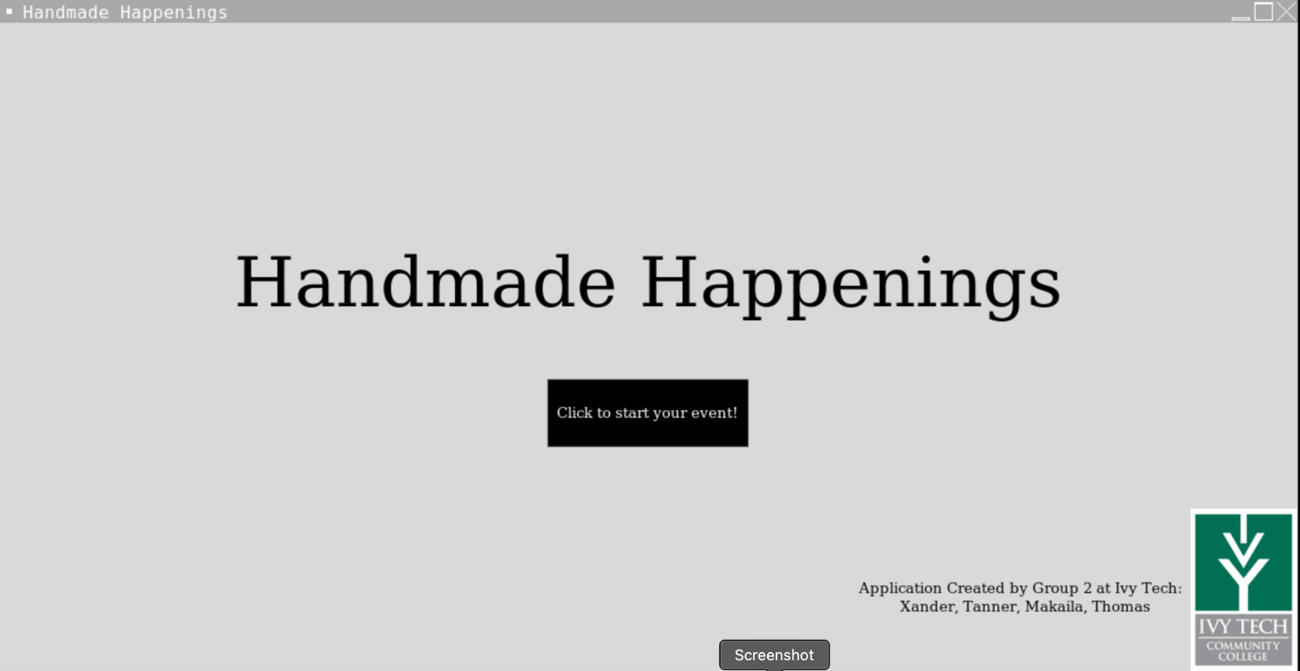

1. **Login Page:**

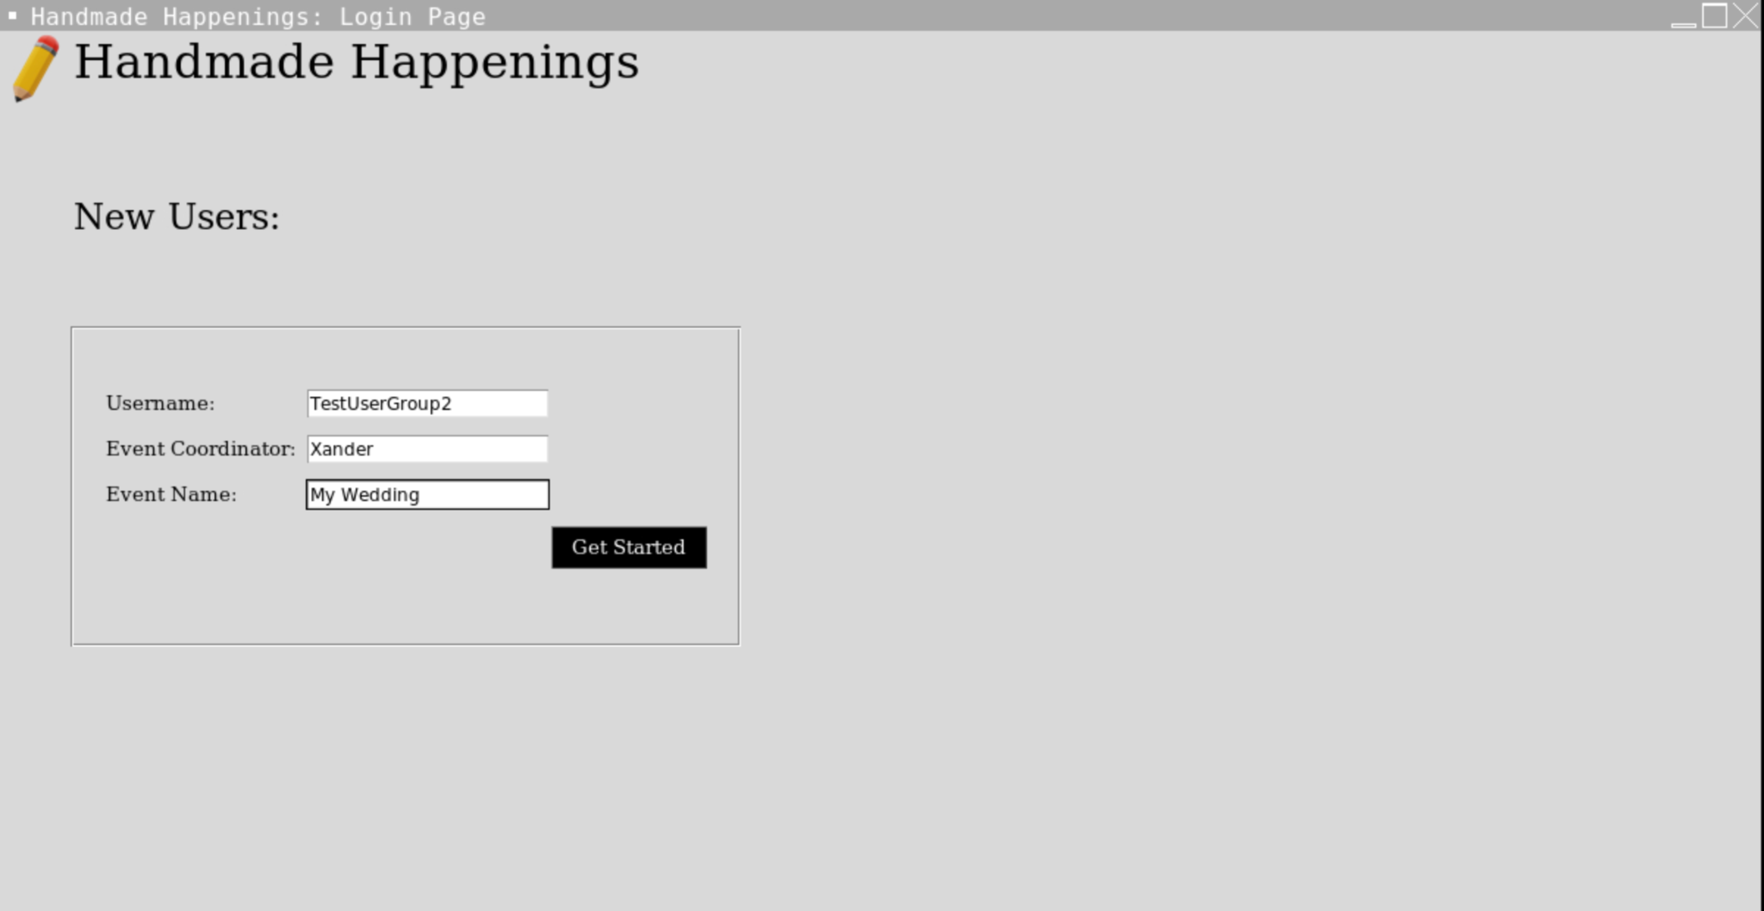

**Screenshots for Test Case (cont.):**

1. **Details Page:**

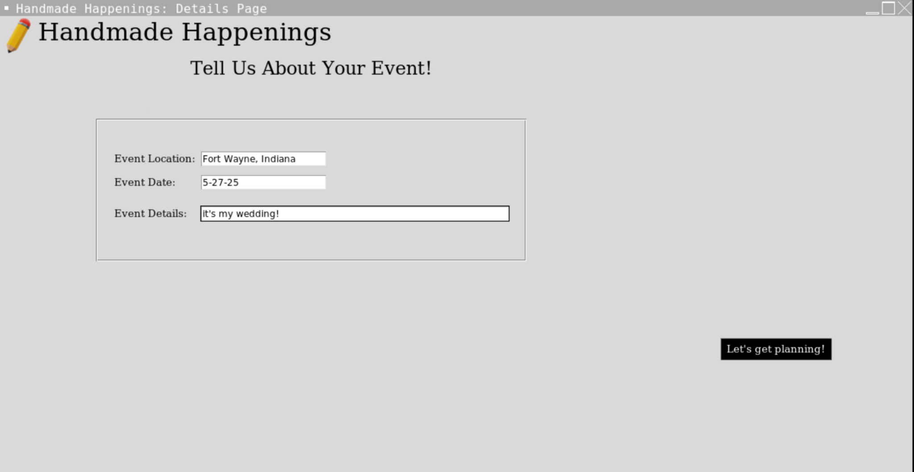

1. **Budget Page (Enter Budget Amount and Pressing “Save Budget” Button):**

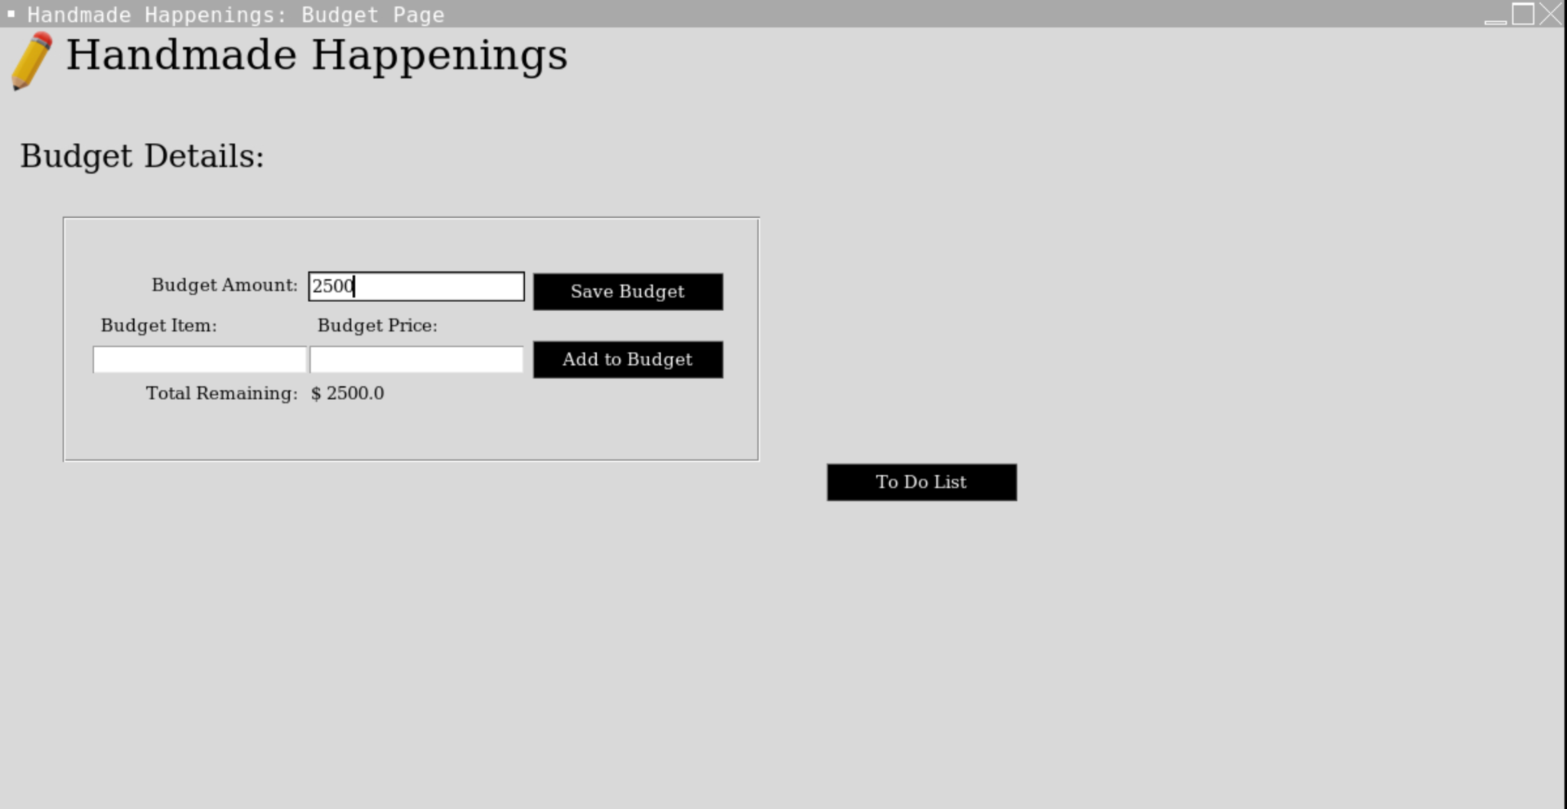

**Screenshots for Test Case (cont.):**

1. **Budget Page (Entering Item Name and item Price, and then Pressing the “Add to Budget Button):**

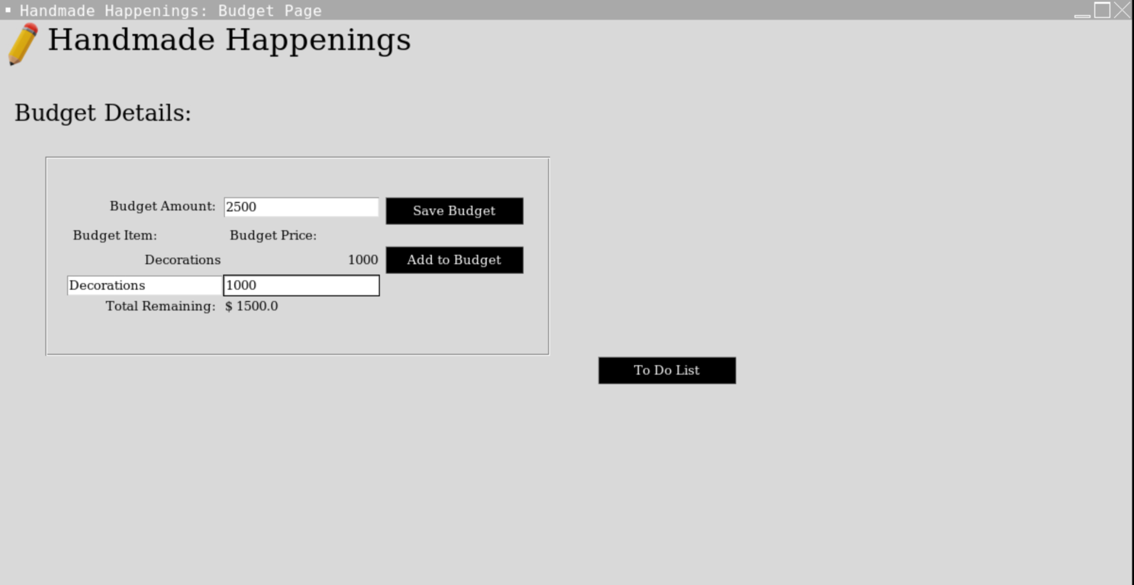

1. **To Do Page:**

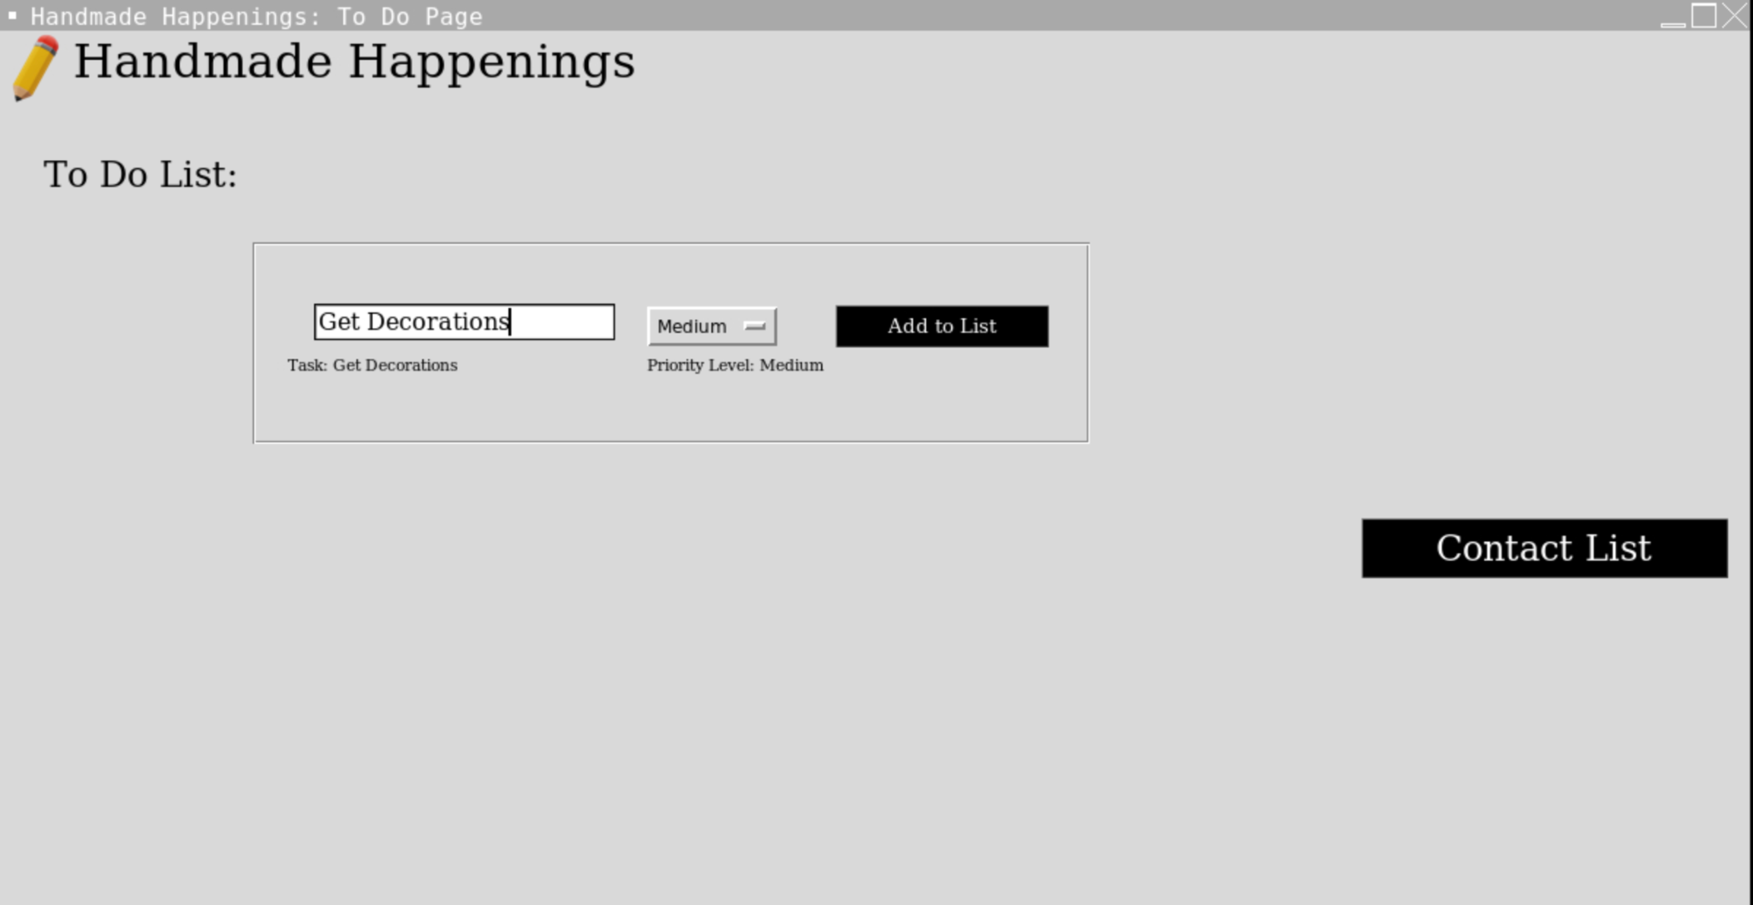

**Screenshots for Test Case (cont.):**

1. **Contact Page:**

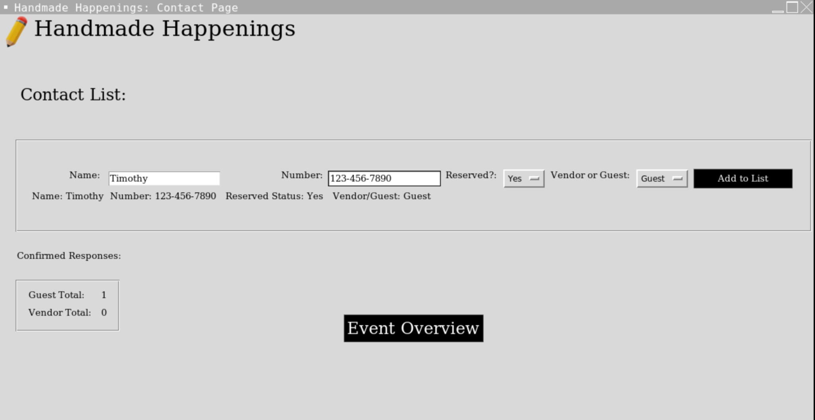

1. **Overview Page:**

